MINDX SERVICE AI

DAY 1 ASSIGNMENT REPORT

Submitted by
Santhoshkumar D
B.Tech Information Technology
Rajalakshmi Engineering College
Date : 05/04/2026

Objective:
To design and develop a backend system for MindX Service AI that handles user queries, creates support tickets, and manages conversation data.
Expected Flow:
1. Customer sends a query
2. System creates a support ticket
3. Messages are stored
4. Admin can view tickets
Technologies Used:
- Java
- Spring Boot
- REST APIs
- MySQL

Features Implemented:
- Created Spring Boot backend project
- Designed database entities (Ticket, Message)
- Implemented REST APIs:
• POST /tickets → Create ticket
• GET /tickets → Get all tickets
• GET /tickets/{id} → Get ticket details with messages
- Stored user messages in database
- Used layered architecture:
Controller → Service → Repository
System Architecture:
The application follows a layered architecture:
- Controller Layer → Handles API requests
- Service Layer → Contains business logic
- Repository Layer → Interacts with database
- Database → MySQL

Flow:
User → Controller → Service → Repository → Database

Screenshots:
Figure 1: POST request using Postman 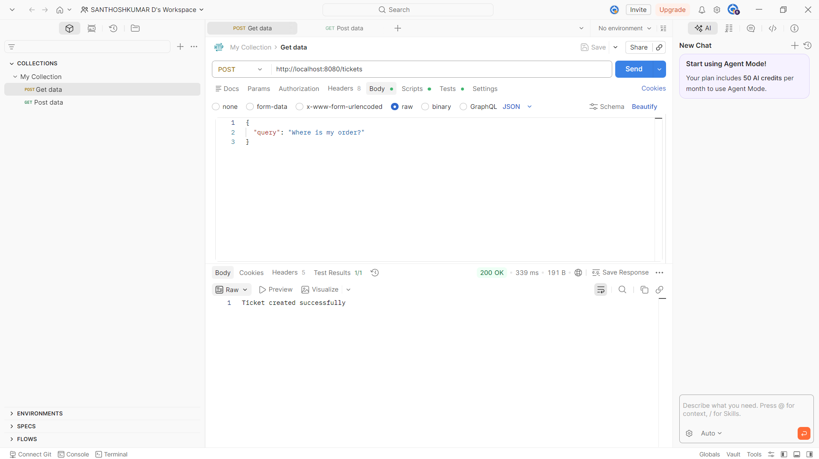

Figure 2: GET /tickets response
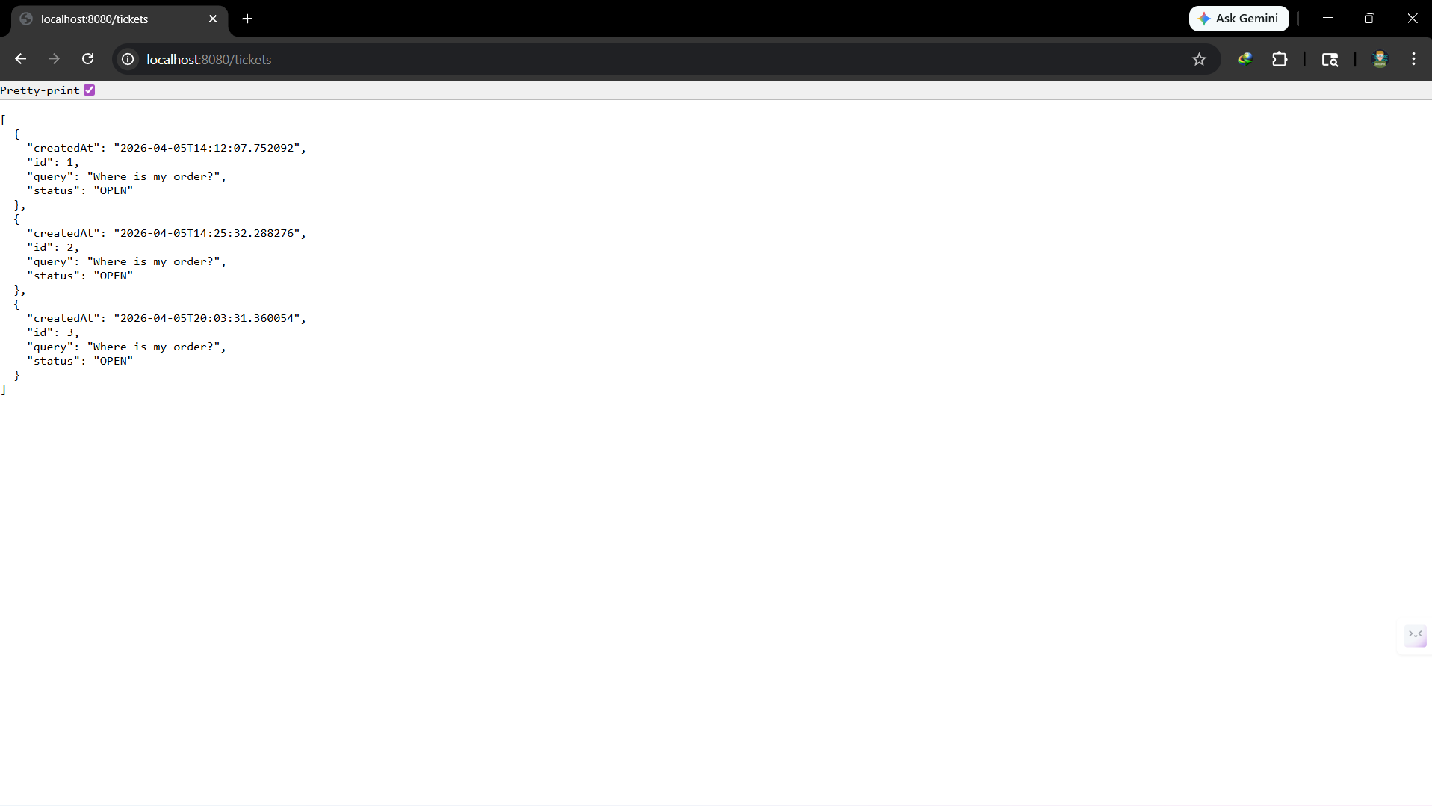

Figure 3: GET /tickets/{id} response
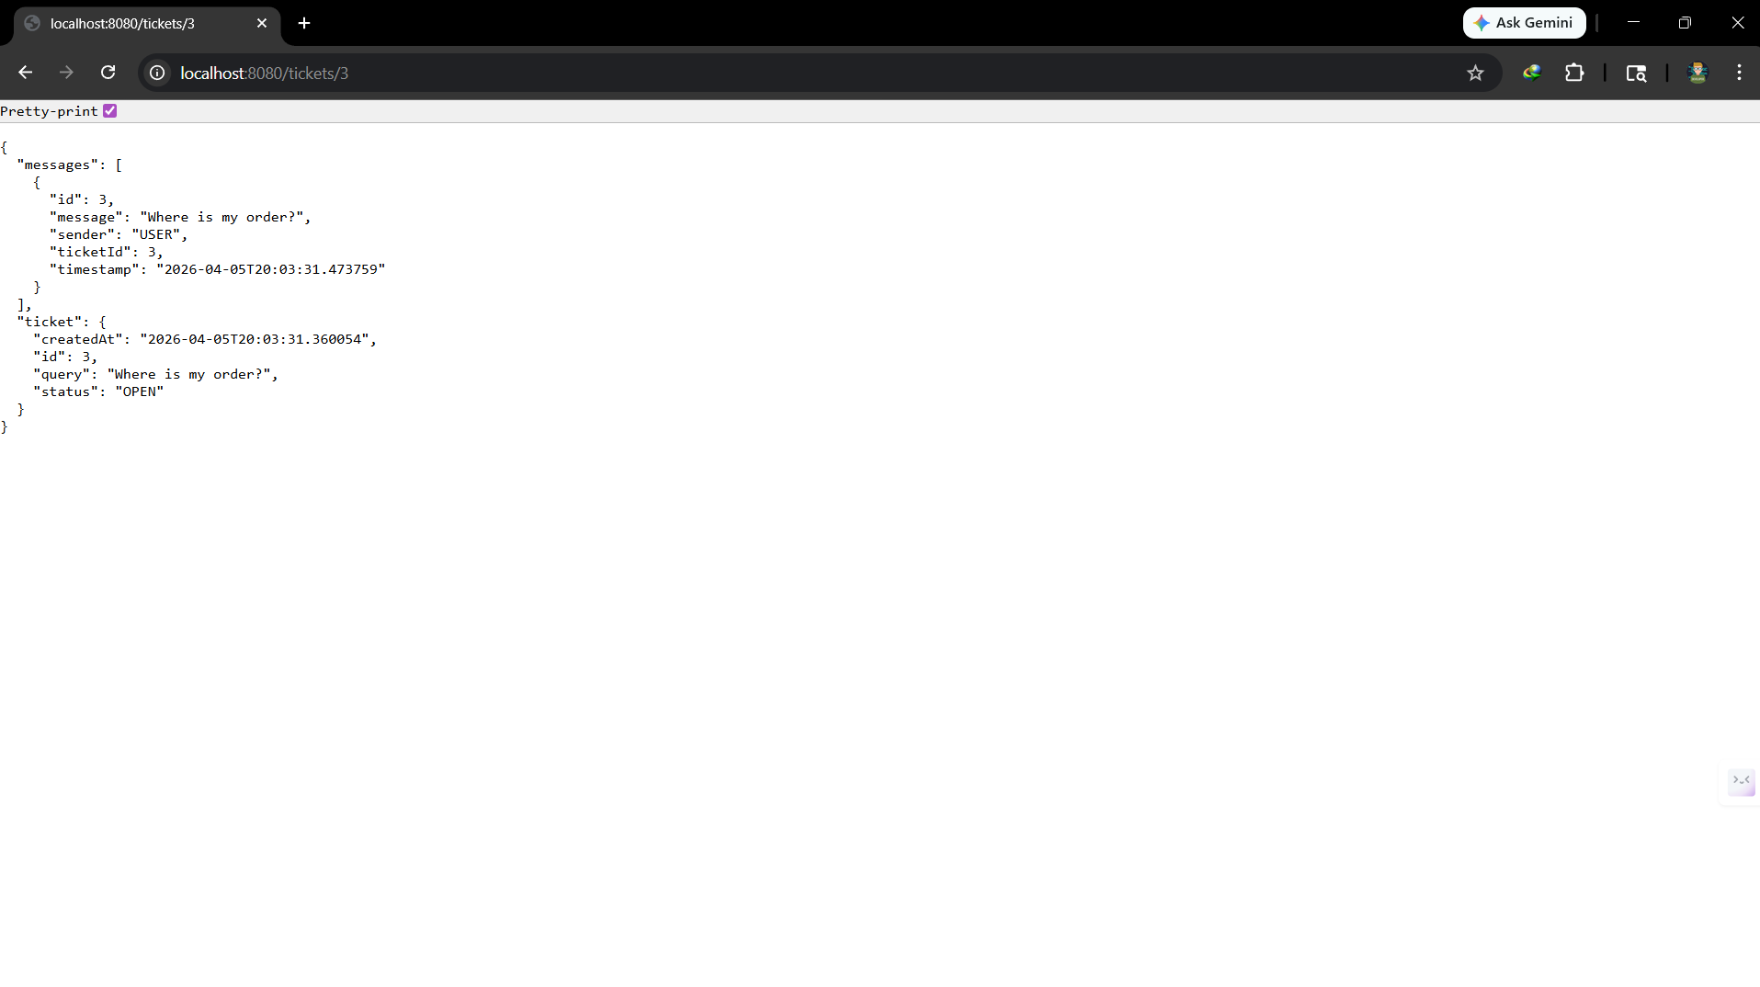

Database:
The data is stored in MySQL database with two tables:
- Ticket table
- Message table

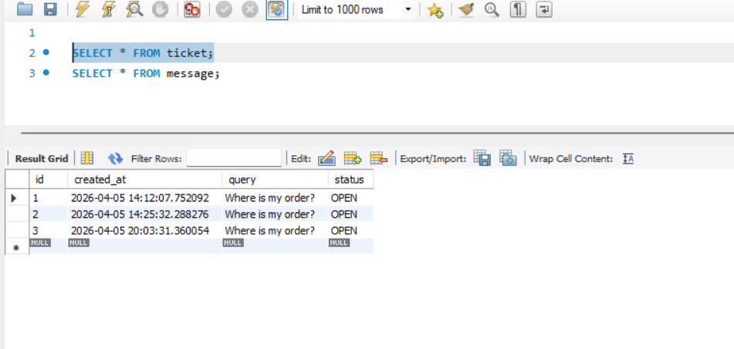
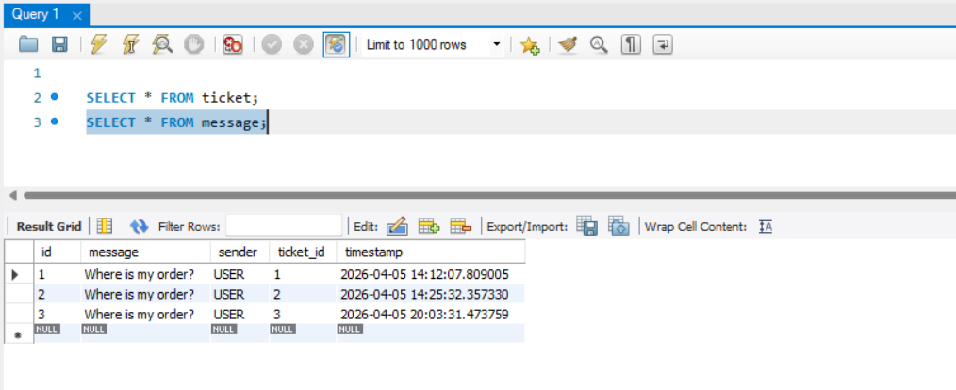
Challenges faced:
- Setting up Spring Boot environment initially
- Understanding request body handling in REST APIs
- Debugging API responses and database connectivity

Conclusion:
Successfully implemented the backend system for ticket creation and message storage. The system is modular, scalable, and follows clean architecture principles.

GitHub Repository:
https://github.com/SANTHOSHDEV22/mindx-support-ai

